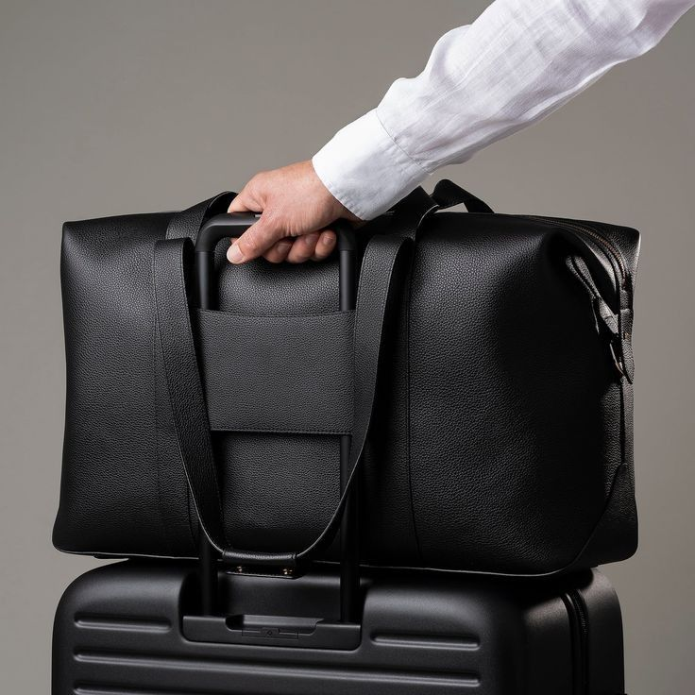Product Details

Product name : Leather travel luggage.

**[**Leather travel luggage **handbag image]**

**Brand : NEXTAG**

**Model : STW-9001-BLK**

**Price: PKR 2,000**

**Description:**

Full-grain leather is the highest quality leather available. It comes from the top layer of the hide, with no sanding or polishing to remove imperfections. As a result, it retains the natural texture and markings of the hide, which adds to its character and authenticity

**Full-Grain Leather**  
**Source:** Top layer of the hide (untreated).

**Thickness:** Varies, generally thicker than other leather types.

**Texture:** Natural texture with visible grain and imperfections, including scars, wrinkles, and marks.

**Durability:** Extremely durable; resistant to cracking and damage over time.

**Patina:** Develops a rich, unique patina as it ages.

**Maintenance:** Requires regular conditioning to keep the leather soft and prevent drying.

**Usage & care Instructions:**

**Avoid Overloading**: Don’t overload your leather handbag with too many items, as this can stretch out

the leather, causing it to lose its shape and leading to wear and tear.

**Warranty Period:** 1 Year from the Date of Purchase

**Warranty Coverage:**

This warranty covers defects in **materials and workmanship**, including:  
✅ Faulty stitching or construction defects  
✅ Hardware issues (e.g., broken zippers, buckles, or metal fittings)  
✅ Leather material defects (excluding natural aging or wear and tear)

**Exclusions:**

This warranty does NOT cover:  
❌ Normal wear and tear, scratches, or stains  
❌ Damage caused by misuse, accidents, or improper care  
❌ Modifications or repairs done by unauthorized persons